### STEP-BY-STEP GUIDE TO DEPLOYING A SPRING BOOT APPLICATION WITH DOCKER AND KUBERNETES 🚀

**NAME : SURYA U S**

**ROLL NO : 22CSR214**

### 

### **STEP 1 : Initialize and Clone the Repository**

Initializes a new Git repository.

Clones the Spring Framework PetClinic project from GitHub.

**Code:**

git init

git clone "https://github.com/AranganathanPrakash/spring-framework-petclinic"

**Screenshot:**

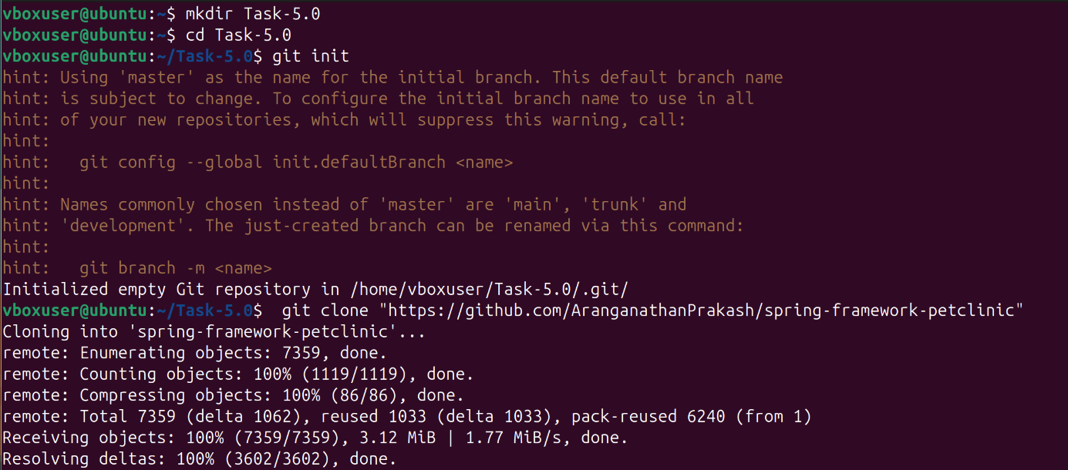

**STEP 2 : Navigate to the Project Directory**

Moves into the cloned repository folder.

**Code:**

cd spring-framework-petclinic

### 

### **STEP 3 : Update System Packages**

Updates the package list to ensure the latest versions are available.

**Code:**

sudo apt update

**Screenshot:**

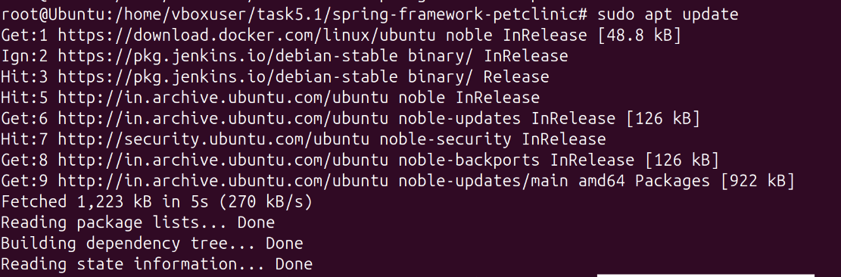

**STEP 4 : Install Maven**

Installs Apache Maven, required for building the Spring Boot application.

**Code:**

sudo apt install maven

**Screenshot:**

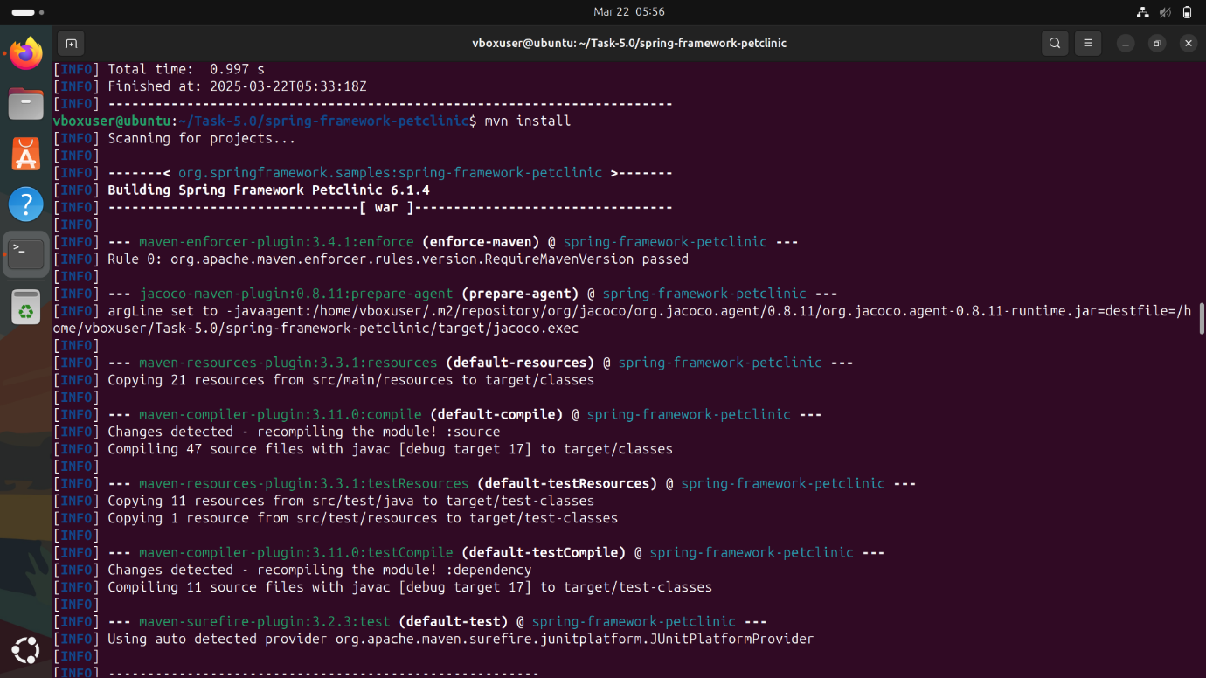

### **STEP 5 : Verify Maven Installation**

Checks if Maven is installed correctly and displays the version.

**Code:**

mvn --version

**ScreenShot:**

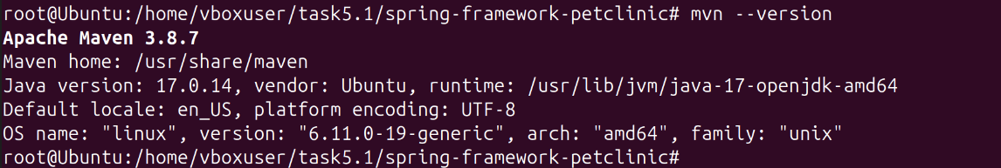

**STEP 6 : Run Tests (Optional)**

Executes unit tests to ensure the application works correctly.

**Code:**

mvn test

**Screenshot:**

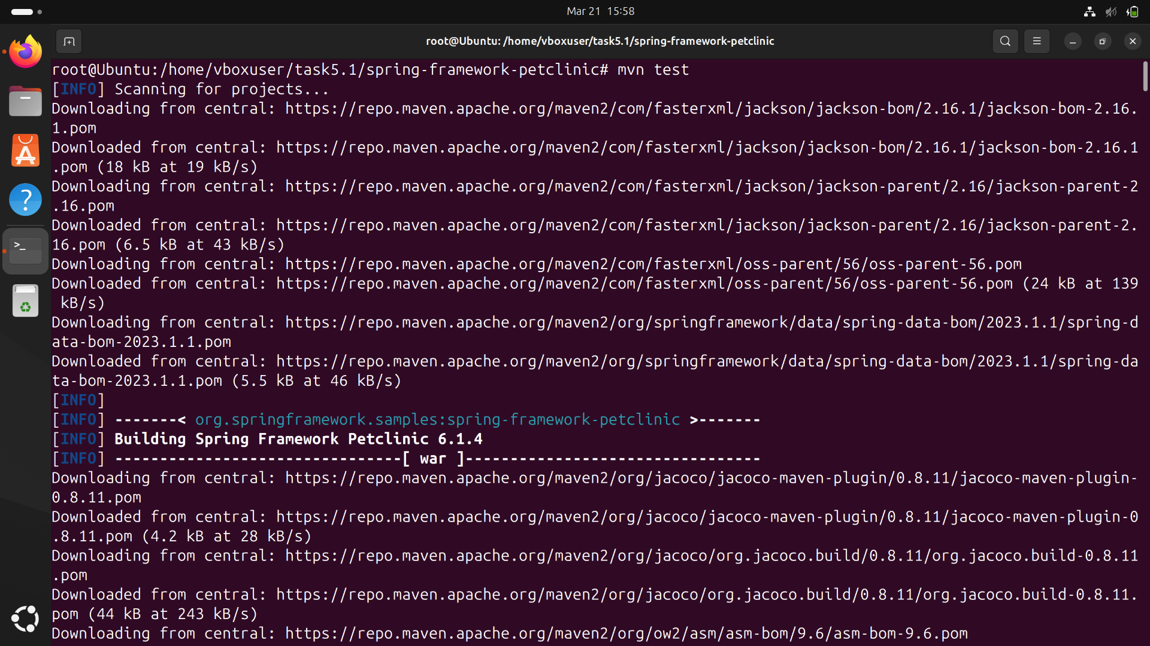

**STEP 7 : Clean and Build the Application**

**mvn clean: Cleans previous builds.**

**mvn install: Compiles and packages the application.**

**mvn package: Generates the final JAR/WAR file in the target/ directory.**

**Code:**

mvn clean

mvn install

mvn package

**Screenshot:**

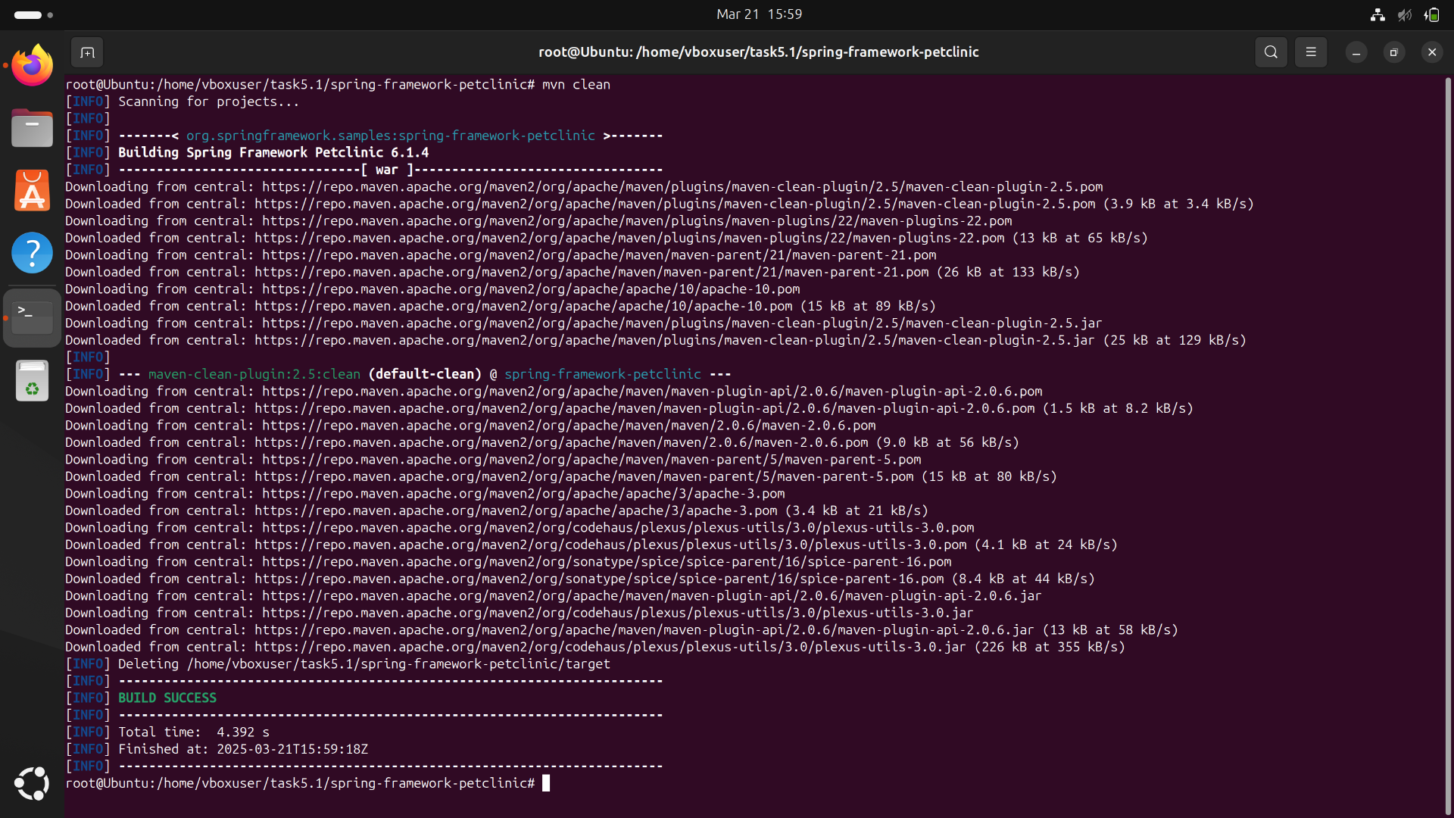

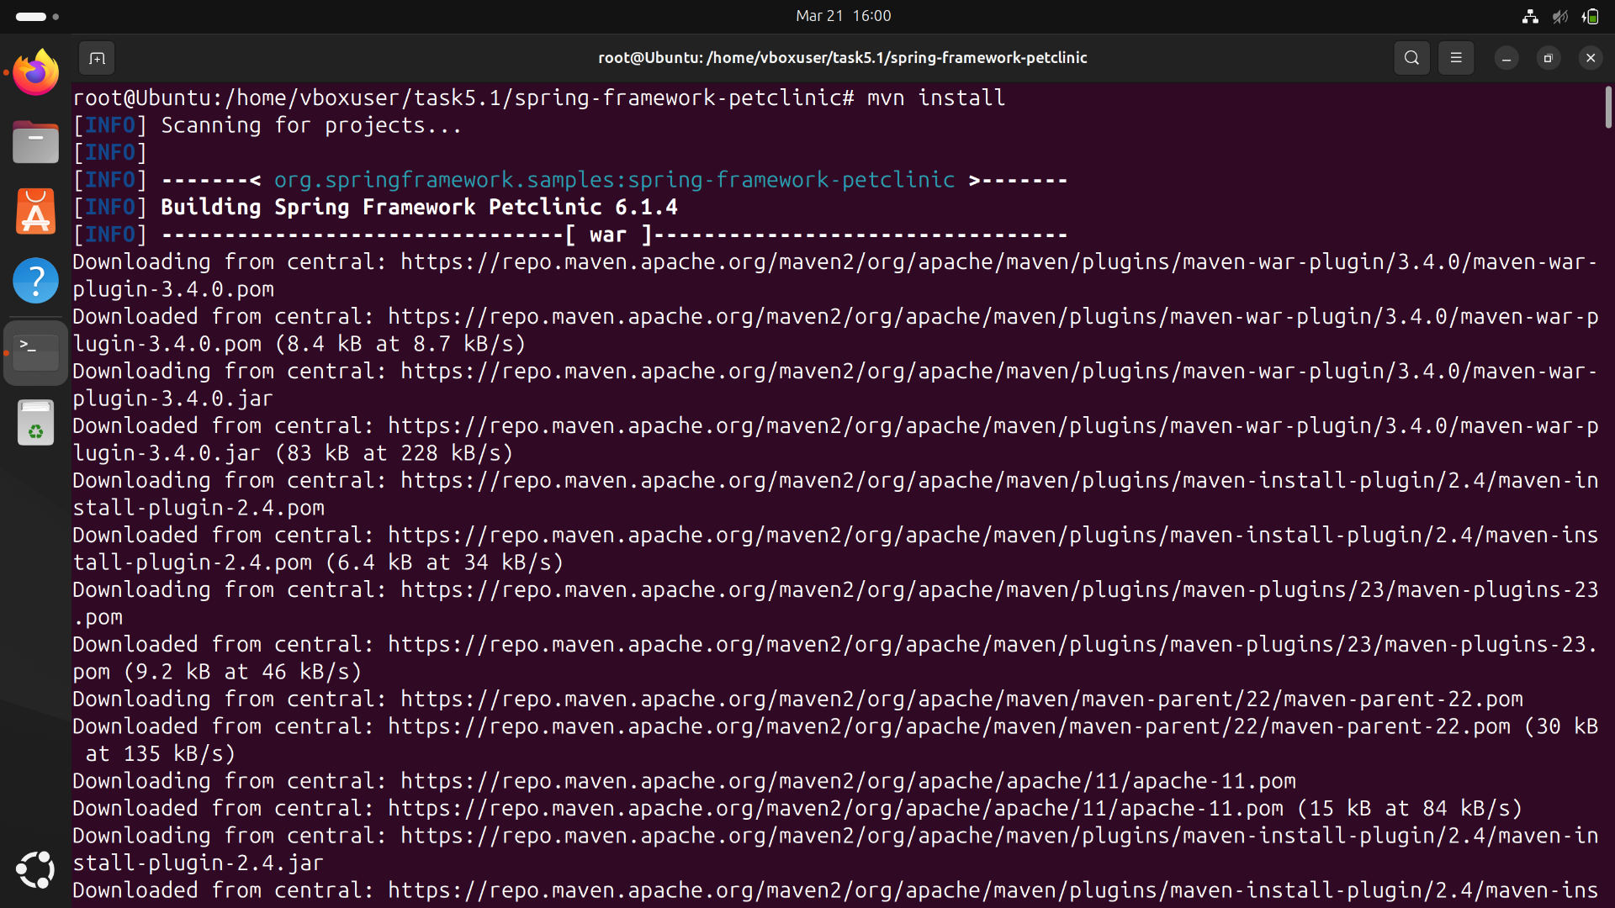

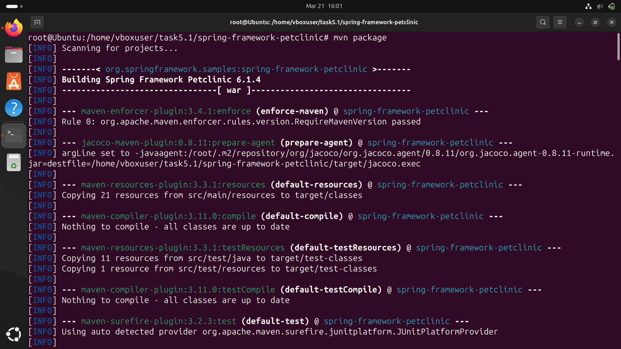

**STEP 8 : Verify the Built Application**

Navigates to the target folder where the compiled application is stored.

**Code:**

cd target

ls

cd ..

**STEP 9 : Login to Docker**

Logs into Docker Hub to push container images.

**Code:**

docker login -u surya22csr214

**Screenshot:**

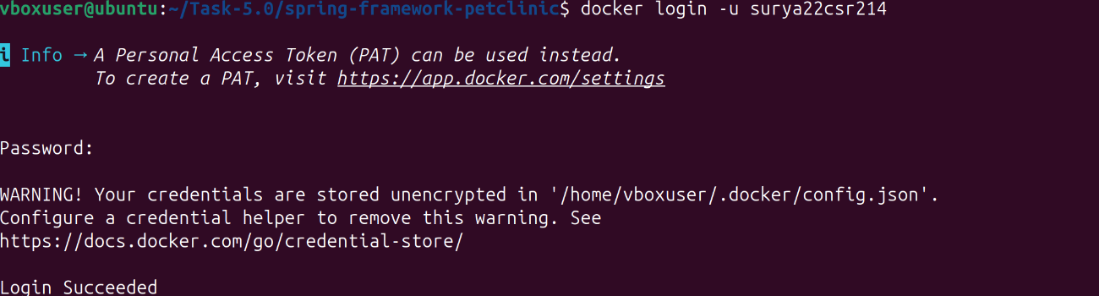

### **STEP 10 : Build Docker Image**

### Builds a Docker image with the tag pet from the project directory.

**Code:**

docker build -t pet .

**Screenshot:**

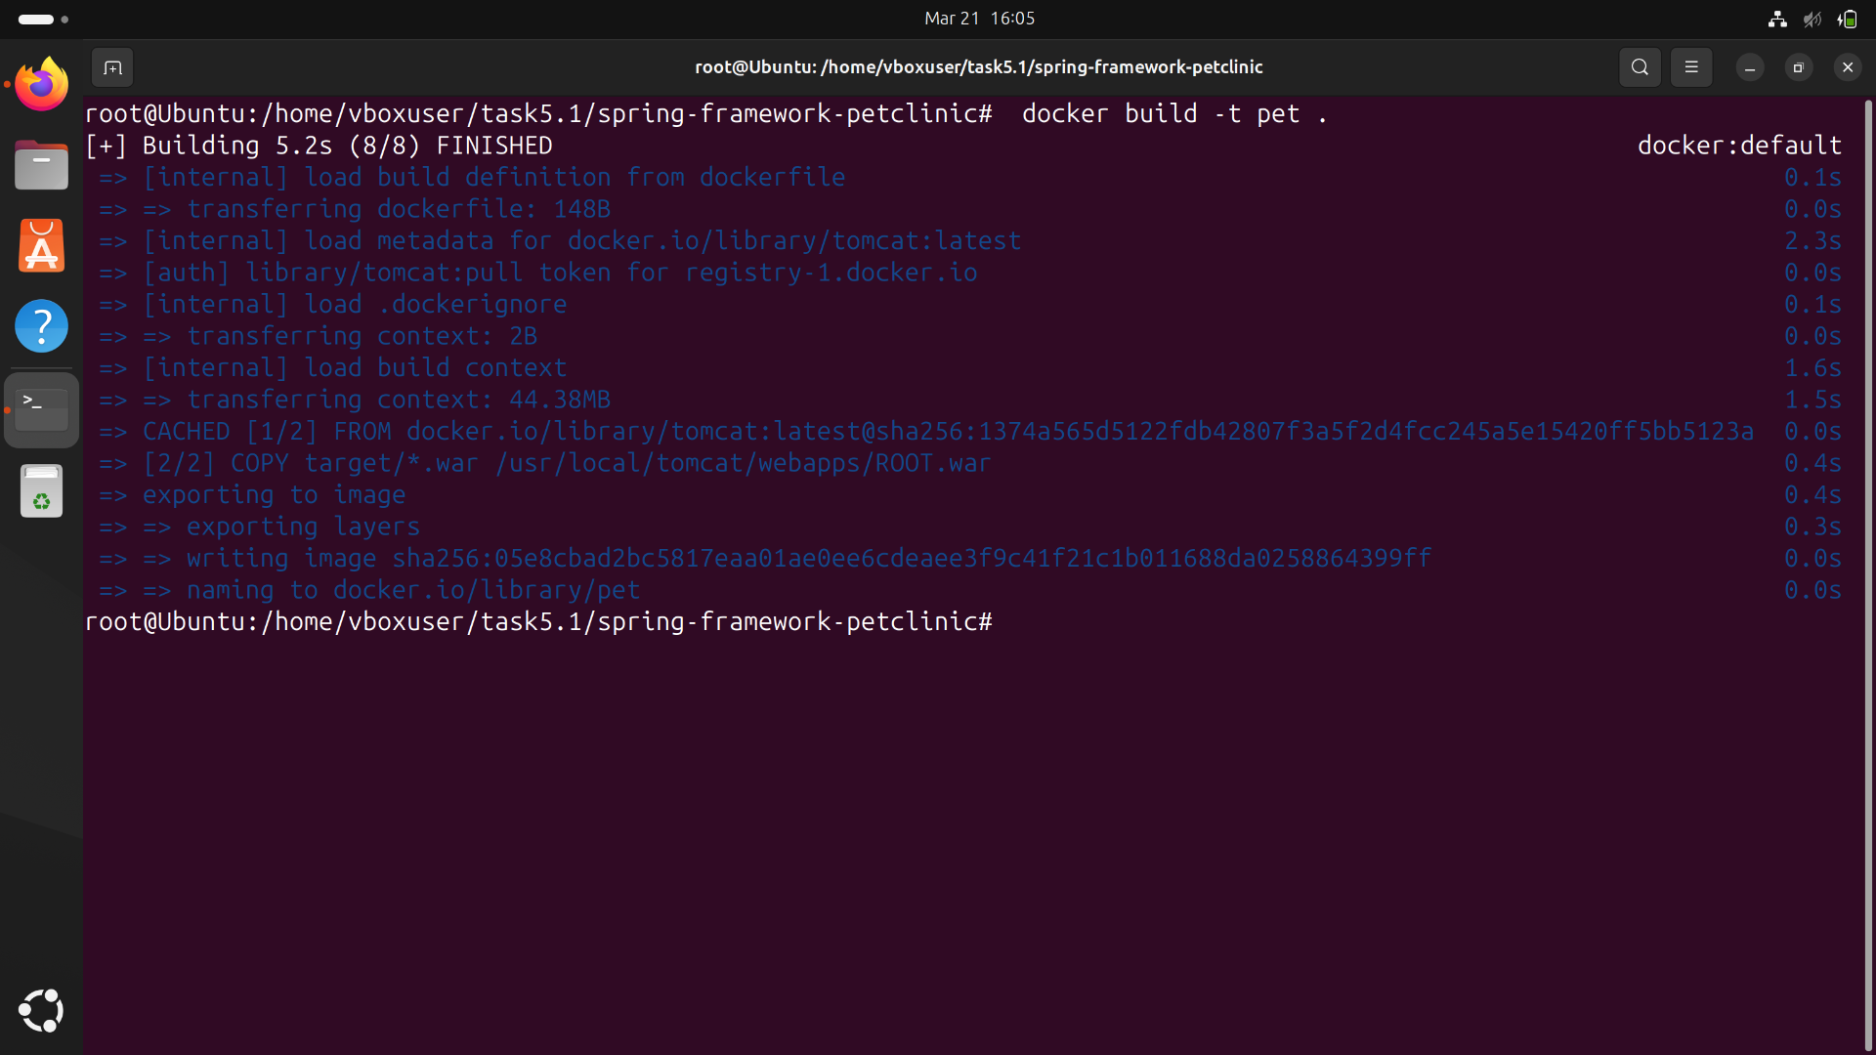

**STEP 11 : Tag and Push Image to Docker Hub**

Tags the image for Docker Hub.

Pushes the image to your Docker Hub repository.

**Code:**

docker tag pet1 surya22csr214/pet1:latest

docker push surya22csr214/pet1:latest

**Screenshot:**

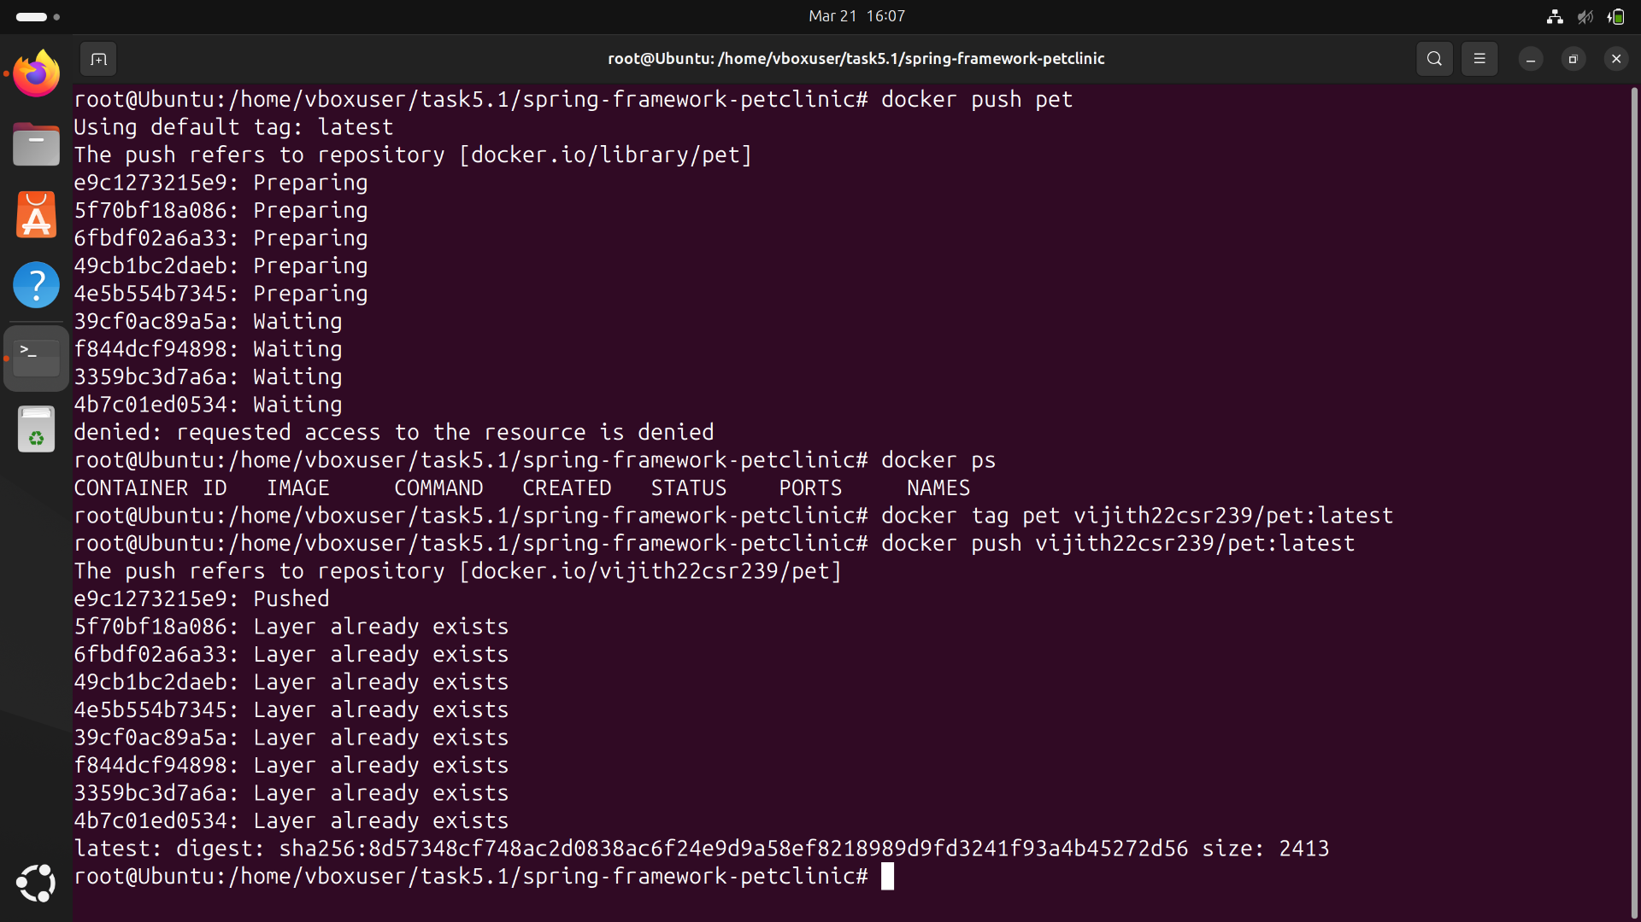

**STEP 12 : Start Minikube**

Starts a Minikube cluster for Kubernetes.

Checks if Minikube is running properly.

**Code:**

minikube start

minikube status

**STEP 13 : Verify Kubernetes Nodes**

Lists available Kubernetes nodes.

**Code:**

kubectl get nodes

**ScreenShot:**

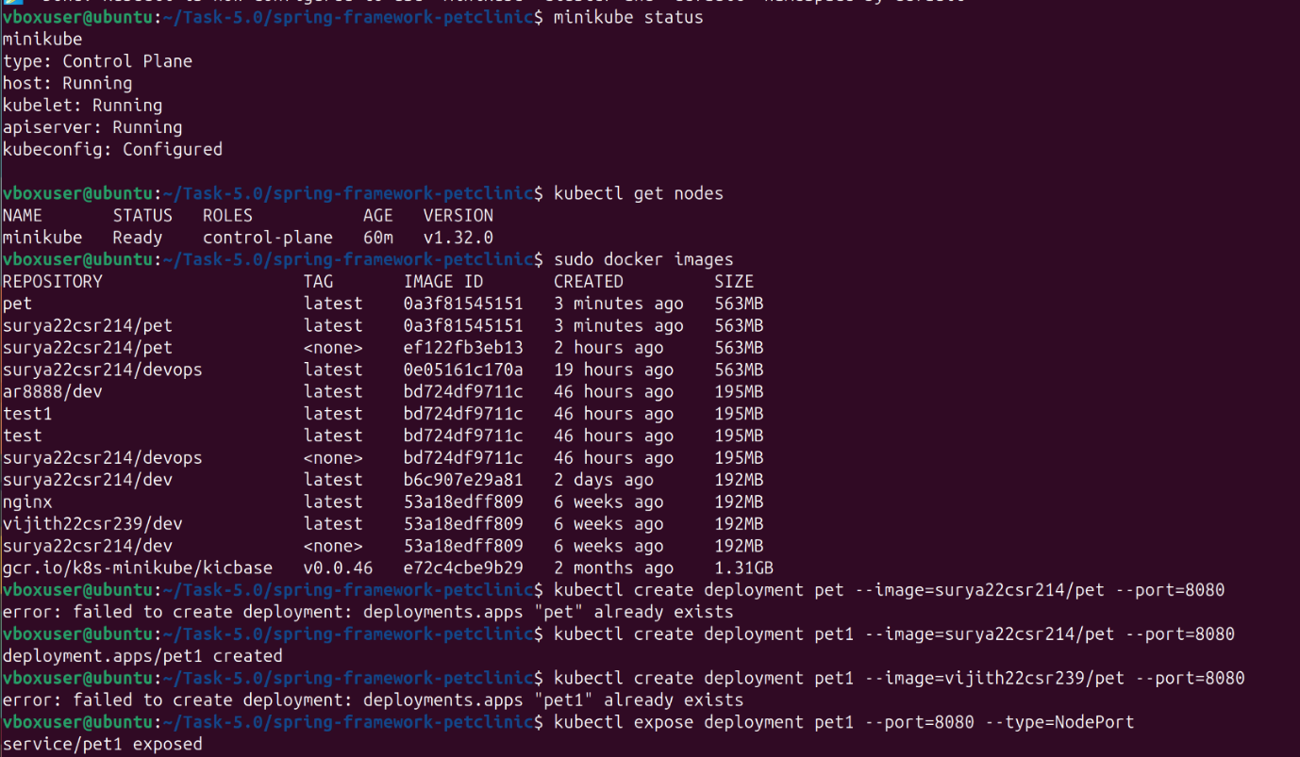

**STEP 14 : Deploy the Application on Kubernetes & Expose the Application**

Creates a Kubernetes deployment using your Docker image.

Exposes the deployment as a service, making it accessible via Minikube.

Lists all running pods to verify the deployment is successful.

**Code:**

kubectl create deployment pet1 --image=surya22csr214/pet1 --port=8080

kubectl expose deployment pet1 --port=8080 --type=NodePort

kubectl get pods

**Screenshot:**



**STEP 16 : Access the Application**

Opens the application in the browser via Minikube.

**Code:**

minikube service pet

**Screenshot:**

